global tourism

Introduction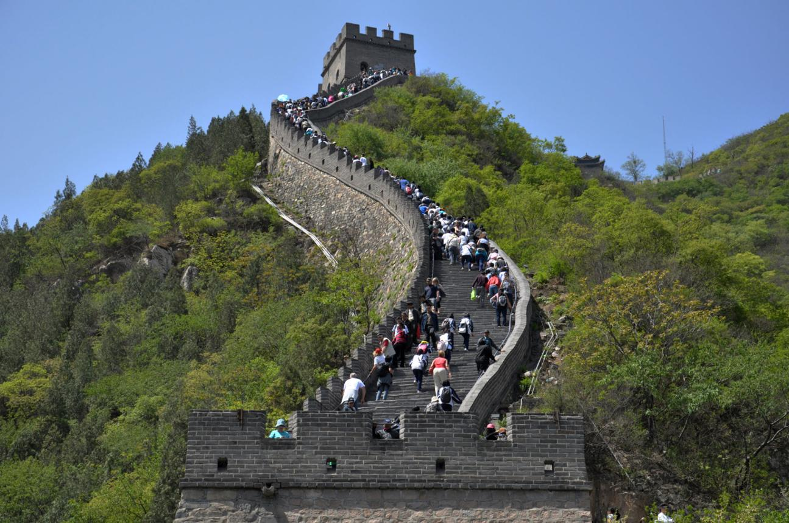
Global tourism stands among the world’s most dynamic and influential sectors, touching nearly every corner of the globe. It includes the movement of people for leisure, business, education, and cultural exploration. As more countries improve their infrastructure and open their borders to international visitors, tourism continues to grow as a major driver of international interaction. This widespread movement of people has transformed entire regions, fostering global connectivity and cultural understanding.
Tourism is not limited to sightseeing. It involves a wide network of industries, including hospitality, transportation, entertainment, retail, and cultural heritage management. These sectors work together to create enjoyable and memorable experiences for travellers. Because of this interconnected structure, even small changes in tourism activity can influence multiple parts of the global economy. This makes tourism an important topic of study for students, policymakers, and business leaders alike.
The purpose of this article is to introduce key themes within global tourism in a clear and accessible way. By exploring its evolution, economic role, cultural effects, environmental pressures, and market trends, learners can gain a better understanding of how tourism shapes the modern world. These insights provide a foundation for meaningful discussions on responsible tourism and sustainable global development.

Tourism Evolution
Tourism has undergone major changes throughout history. In ancient civilizations such as Greece and Rome, people travelled for festivals, education, and trade, but these journeys were limited to the wealthy. During the Middle Ages, religious pilgrimages became a dominant reason for international travel. Travel remained slow, dangerous, and expensive until new technologies emerged in the 18th and 19th centuries.
The Industrial Revolution marked the beginning of mass tourism. Railways made travel faster and more affordable, opening the world to middle‑class leisure travellers. By the early 20th century, automobiles and steamships increased mobility even further, and organised tours became popular. After World War II, developments in road networks, commercial aviation, and global communication made international travel accessible to millions of people.
Today, digital tools such as online booking systems, social media, and mobile navigation apps have transformed tourism once again. People can research destinations instantly, compare prices, and share experiences online. Low‑cost airlines have reduced travel expenses, while digital marketing inspires travellers with images and videos from around the world. Tourism continues to evolve as technology shapes new expectations and ways of exploring.

Economic Significance
Tourism plays a major economic role in many countries by generating income, creating jobs, and stimulating investment. When travellers spend money on hotels, restaurants, attractions, and transport, they contribute directly to economic growth. This revenue supports national budgets through taxes and provides essential funding for public services such as healthcare, education, and transport infrastructure.
In addition to direct spending, tourism has strong indirect benefits. Industries that support tourism—such as agriculture, construction, retail, and manufacturing—also experience increased demand. For example, hotels depend on farmers for food supply, and airlines rely on engineering and fuel industries. This interconnectedness means that tourism can stimulate broad economic activity even in regions that do not host large numbers of visitors.
Tourism also produces induced economic effects. When tourism workers earn wages, they spend them in their communities on groceries, housing, clothing, and other needs. This increases local spending and supports further job creation. For many developing countries, tourism is one of the few stable sources of foreign income. However, if not managed properly, tourism can become overly dependent, making economies vulnerable to global crises such as pandemics or natural disasters.

Social and Cultural Impacts
Tourism promotes meaningful cultural exchange as travellers learn about new traditions, languages, and customs. This cultural interaction can strengthen mutual respect and reduce stereotypes by exposing people to different ways of life. For host communities, tourism provides opportunities to share their heritage, perform arts, preserve historical sites, and celebrate cultural diversity.
However, tourism can also create social challenges. Popular destinations sometimes experience overcrowding, which can strain public services and reduce the quality of life for local residents. High tourist demand may increase the cost of housing, transportation, and basic goods. These pressures can create tension between tourists and residents, especially when visitor behaviour conflicts with local customs or disrupts community routines.
Cultural dilution is another concern. When traditions are changed or simplified to attract tourists, they may lose their original meaning. Local crafts, dances, or rituals can become commercialised, shifting focus from cultural pride to profit. To avoid these negative impacts, communities must balance tourism development with cultural preservation, ensuring that local voices and values remain central to tourism planning.



Environmental Impacts
Tourism can place significant strain on natural environments. Increased travel leads to higher carbon emissions, particularly from cars, buses, and airplanes. Popular tourist sites often face waste disposal challenges, pollution, and overcrowding. Sensitive ecosystems such as coral reefs, forests, and wetlands may be damaged by heavy foot traffic, boating activities, or unregulated development.
Water and energy use also increase sharply in tourist areas. Hotels, resorts, and entertainment facilities require large amounts of resources to operate. In regions with limited water supply, tourism can compete with local communities for essential resources. This can lead to unsustainable consumption patterns, especially during peak seasons when visitor numbers surge.
Sustainable tourism practices aim to reduce these environmental impacts. Examples include eco‑friendly accommodations, renewable energy use, waste‑reduction programmes, and strict guidelines for wildlife and habitat protection. Educating tourists about responsible behaviour—such as staying on designated trails, reducing waste, and respecting natural habitats—can help protect the environment for future generations.

Market Trends
Modern tourism is shaped by rapid technological and social changes. Social media platforms influence where people travel, as travellers seek destinations that offer unique experiences worthy of sharing online. Mobile apps allow users to compare prices, find directions, read reviews, and book services instantly. Technology has created a more informed and independent traveller.
Eco‑tourism is another major trend. As environmental concerns grow, many travellers seek destinations that promote conservation and sustainability. These tourists prefer nature‑based activities, green accommodations, and travel experiences that support local communities. This shift encourages tourism businesses to adopt eco‑friendly policies to attract environmentally conscious visitors.
Experiential travel has also become increasingly popular. Instead of traditional sightseeing, travellers seek authentic, hands‑on experiences such as cooking classes, cultural workshops, volunteer projects, and adventure activities. This trend emphasises emotional connection, personal growth, and cultural immersion. As a result, destinations are developing more creative and personalised tourism products to meet evolving expectations.

Conclusion
Tourism remains one of the world’s most powerful forces, influencing economies, societies, environments, and cultures. Its ability to create jobs, promote development, and encourage global understanding makes it a valuable sector for many countries. At the same time, it requires careful planning to prevent environmental damage, cultural loss, and negative social impacts.
With thoughtful management and sustainable practices, tourism can continue to grow while protecting the communities and natural areas that make destinations unique. Governments, businesses, and travellers must work together to create responsible tourism systems. This includes reducing waste, supporting local cultures, and ensuring that tourism benefits are shared fairly.
For future generations, responsible travel habits are essential. By learning about global tourism’s opportunities and challenges, Grade 11 learners can develop informed perspectives on how to support sustainable and respectful tourism. The future of global travel depends on choices made today, and with proper stewardship, it can remain a positive force for the world.

